Exercise: Build a sample few pages to help facilitate a library book lending application according to the following requirements. You have been given an access to the database with the library table structure and some prepopulated data, access to and all the necessary development tools including help files and the Internet to look up resources if you wish.

**» Front-End solution:**

Please use the given API URL below to build your single page application. You can use any base project or template for your application.

The link to the API:  
https://aka-library-api.azurewebsites.net/docs

You can send the solution in a zip format upon completion to diane@akanewmedia.com.

**Technical Requirements:**

Follow these in order. There may not be time to implement it all. Use your time judiciously

1. Display the entire list of Library building and allow the user to choose one.
2. Change the list of books assigned to the library to display only available books for that library. A book is not available if all copies are signed out. The user can choose a book.
3. Let the user sign out one book at a time. Multiple copies of that book can be signed out. Validation will be enforced as follows:
   1. The user cannot sign out more copies than are available of that book.
   2. A valid membership ID must be input.
4. The member can return a book.

Create a separate page to return the book if there is any. Put this link in “Libraries” page. The return page will ask for membership ID and then display a list of the books under this member. A “Return” link should be available beside each book. The user can click on the “Return” link to return the book. (The book ID, library ID, and member ID are known here.)

1. Enforce this restriction No member can have more than two books signed out of the library at any one time.
2. Allow multiple (different) books to be signed out by a member at once.

Keep it simple because there is a time limit.

**Data Schema**

Following is the database schema. Sample data already exists in these tables so you can start coding logic. The database schema is there only for your reference and to help you to build the logic.

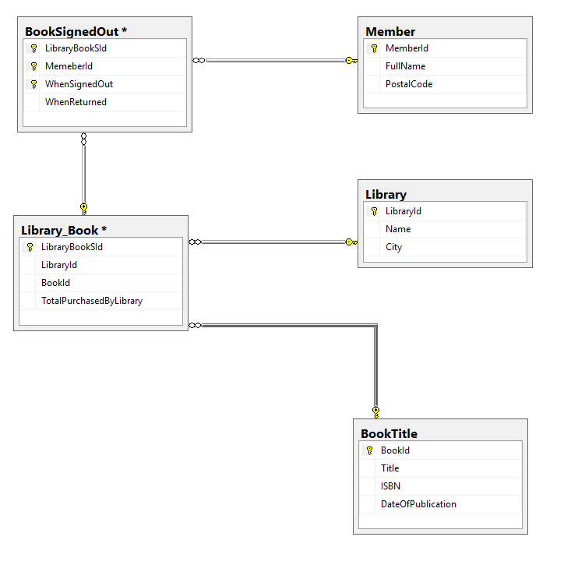

Each record represents a book signed out of the library by a member. A member can sign out multiple books. The sign-out will be marked returned eventually.

Each record represents a person (a card-carrying member of the library who can sign out books).

Each record is info about a book owned by the library. 'LibraryBookSld' is a surrogate ID representing LibraryId+BookId. ('There is also a unique constraint put on Libraryld + BookId). 'TotaIPurchasedByLibraryy' is how many of that book is owned by the library no matter if it is signed out or not right now.

Each record represents one library building.